WORK 3

CHANDELIERS

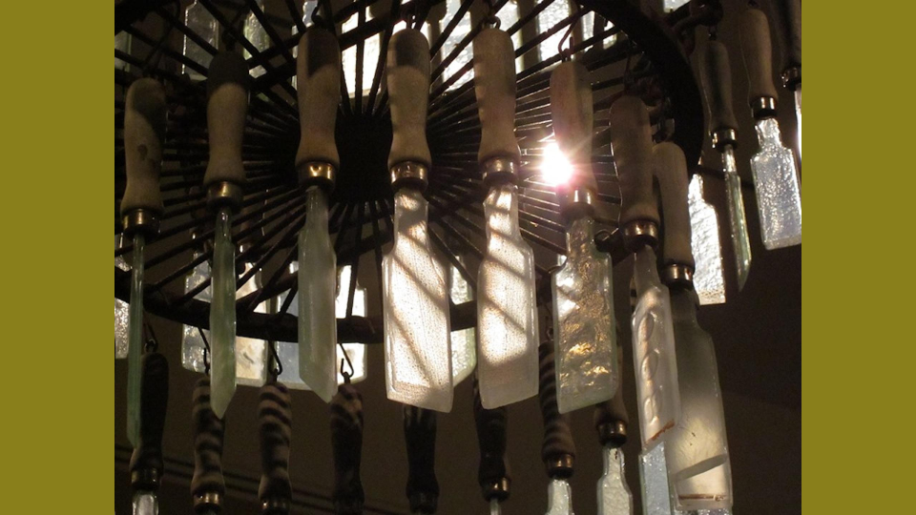

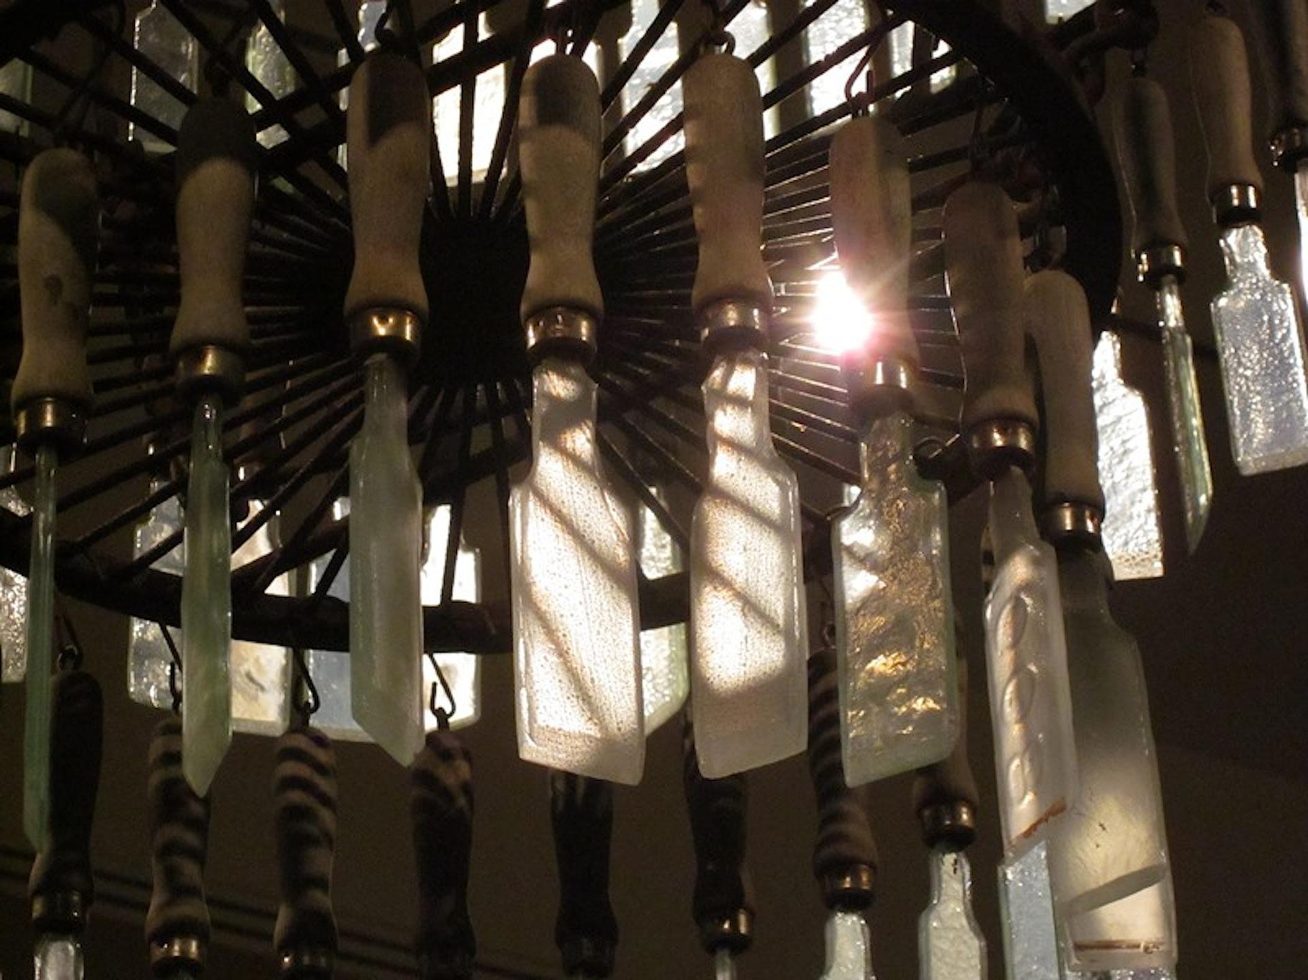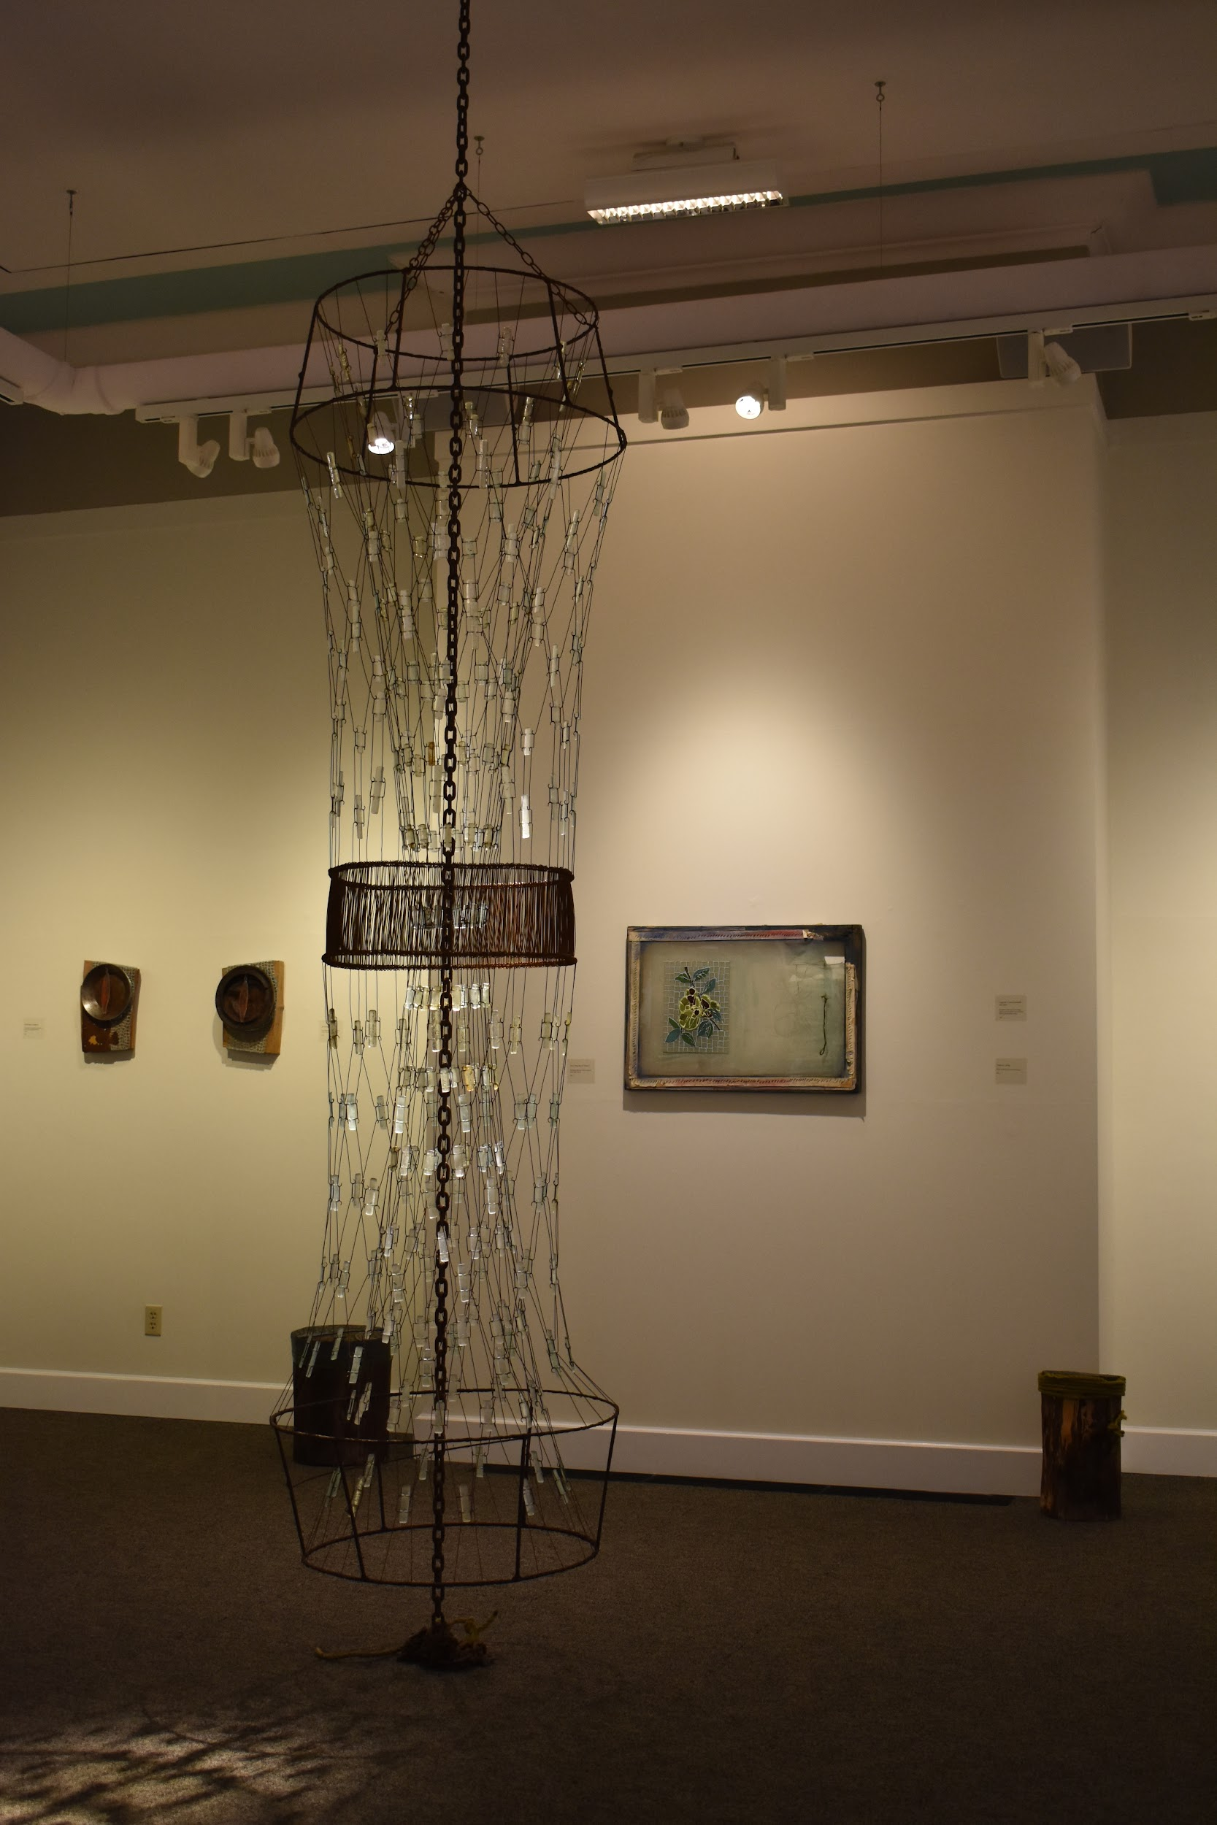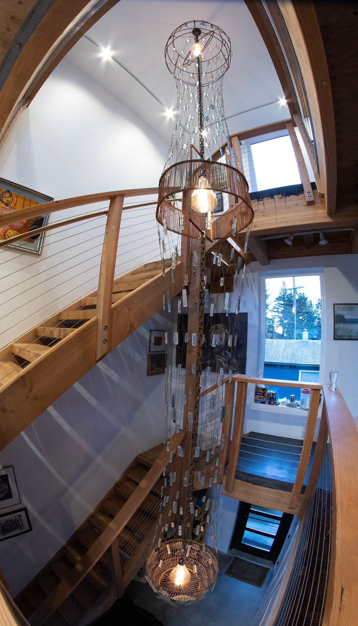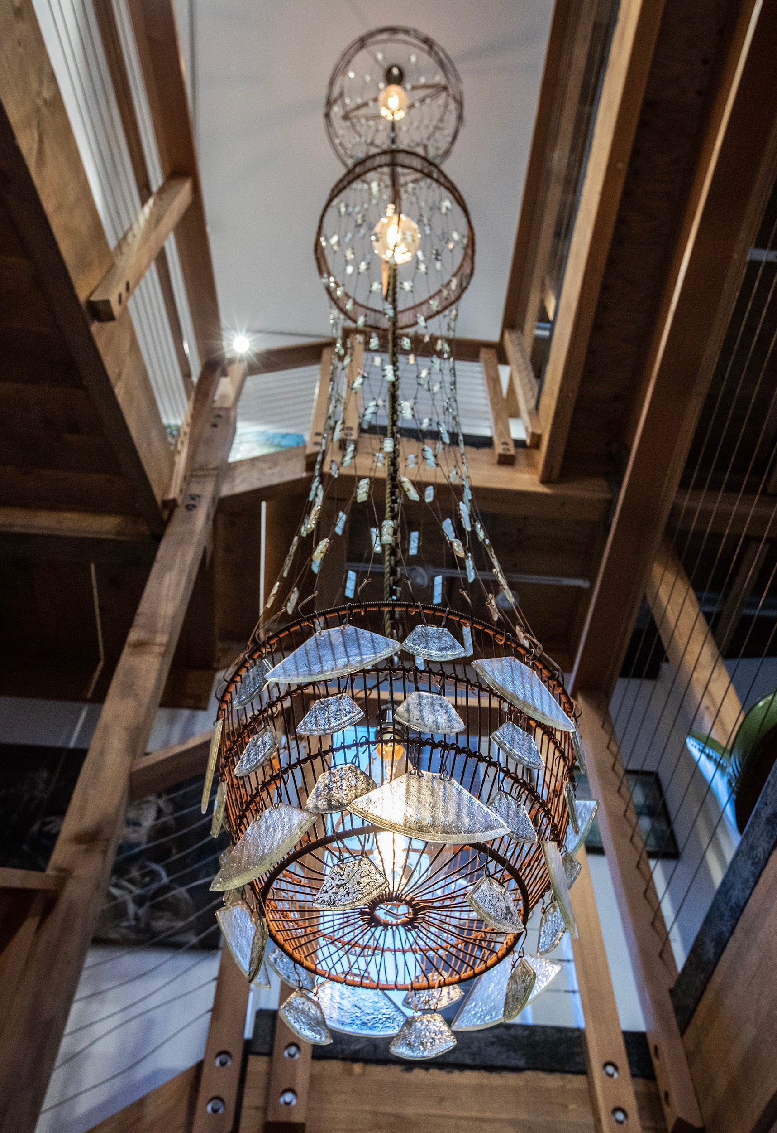**P & R Chandelier**

**Kiln fused glass, kiln cast glass, found metal and rebar ties, lighting**

**22 x 3 x 3’**

**2021**

**Private Residence - Juneau, AK**

Created as a commissioned piece, this chandelier spans three floors, supported by an anchor chain, with each level containing a lighting element. The top floor viewed from the client's artist studio is created from multiple cast glass paint brushes suspended from a reclaimed shrimp pot. Attached to the shrimp pot and suspending the work at the levels below are rebar ties and kiln fused glass pendants designed in a netting pattern. The center lighting element, viewed from the kitchen and living areas is constructed from found metal and rebar ties welded in a circle creating a lightshade. The netting of rebar ties and glass pendants continues to the lower level and is built from a found metal basket and ulu shaped pendants. The entire structure weighs under 30 pounds, the heaviest element being the supporting anchor chain.

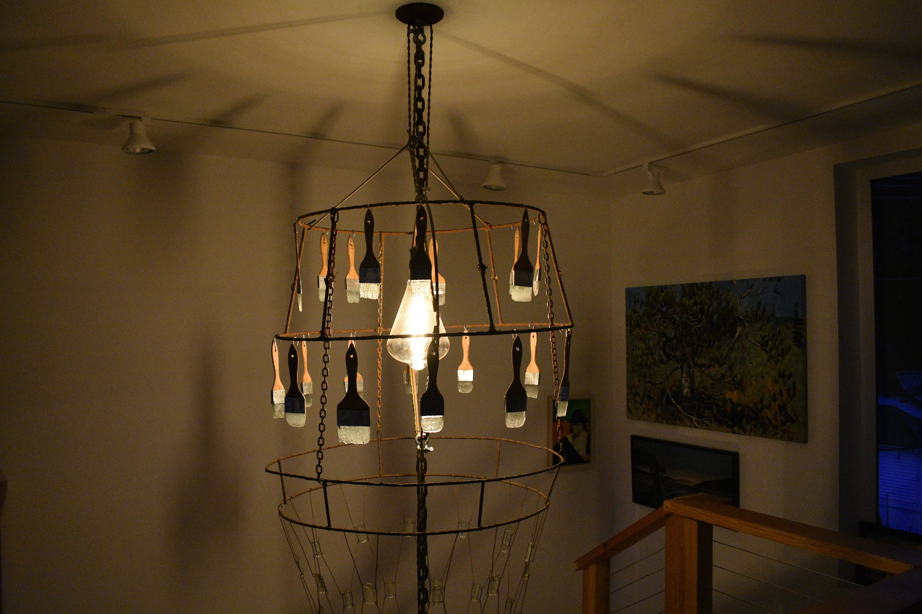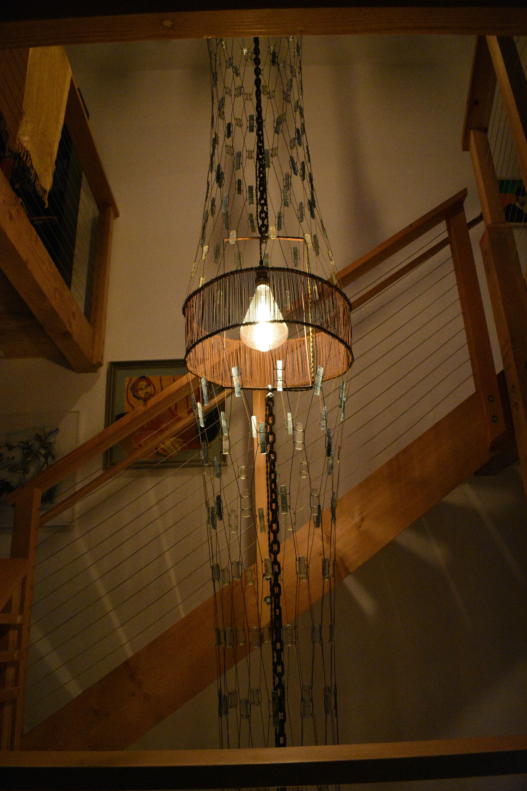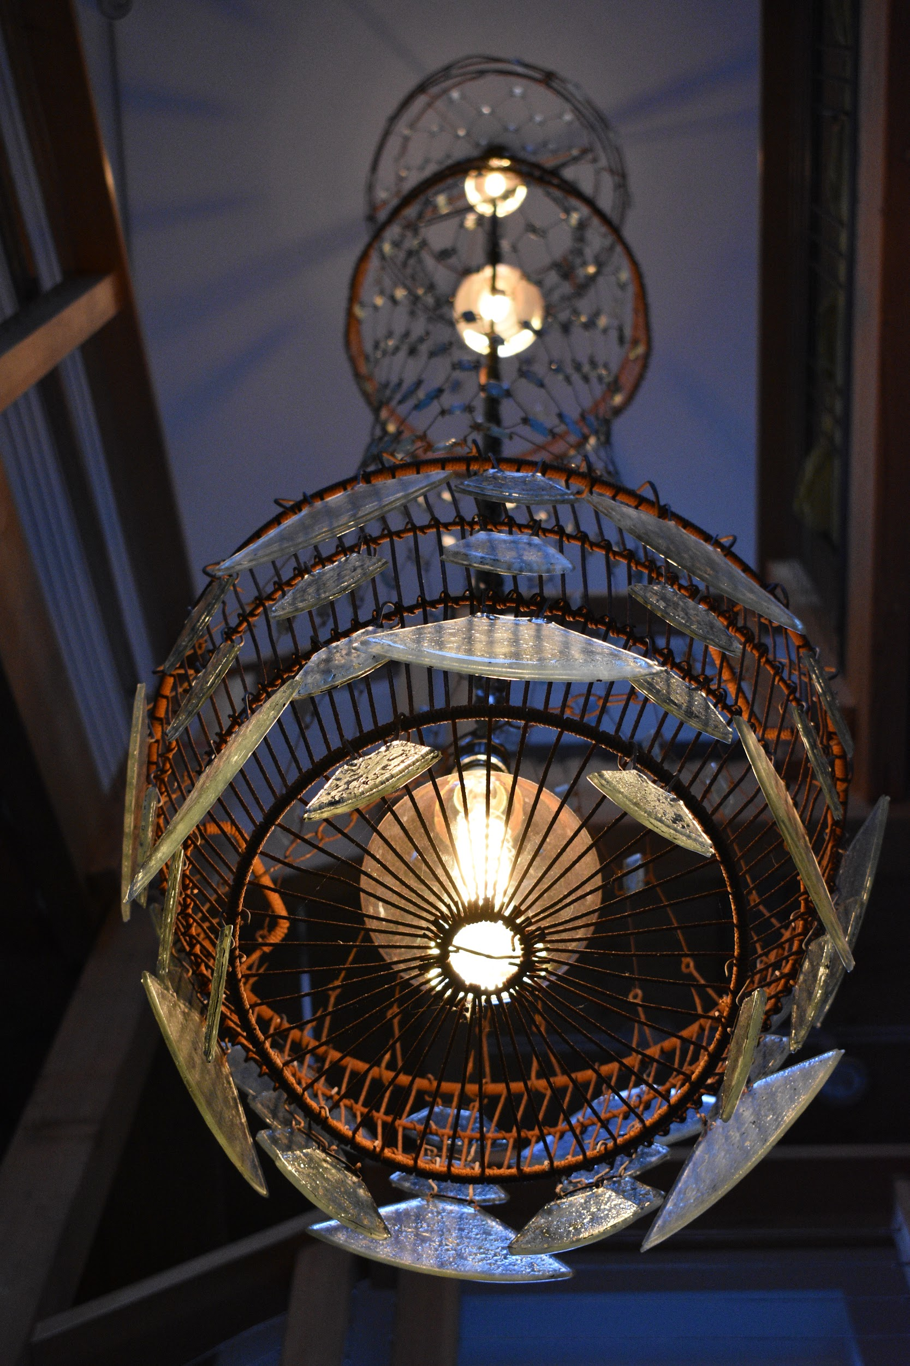

ALASKA ROBOTICS CHANDELIER

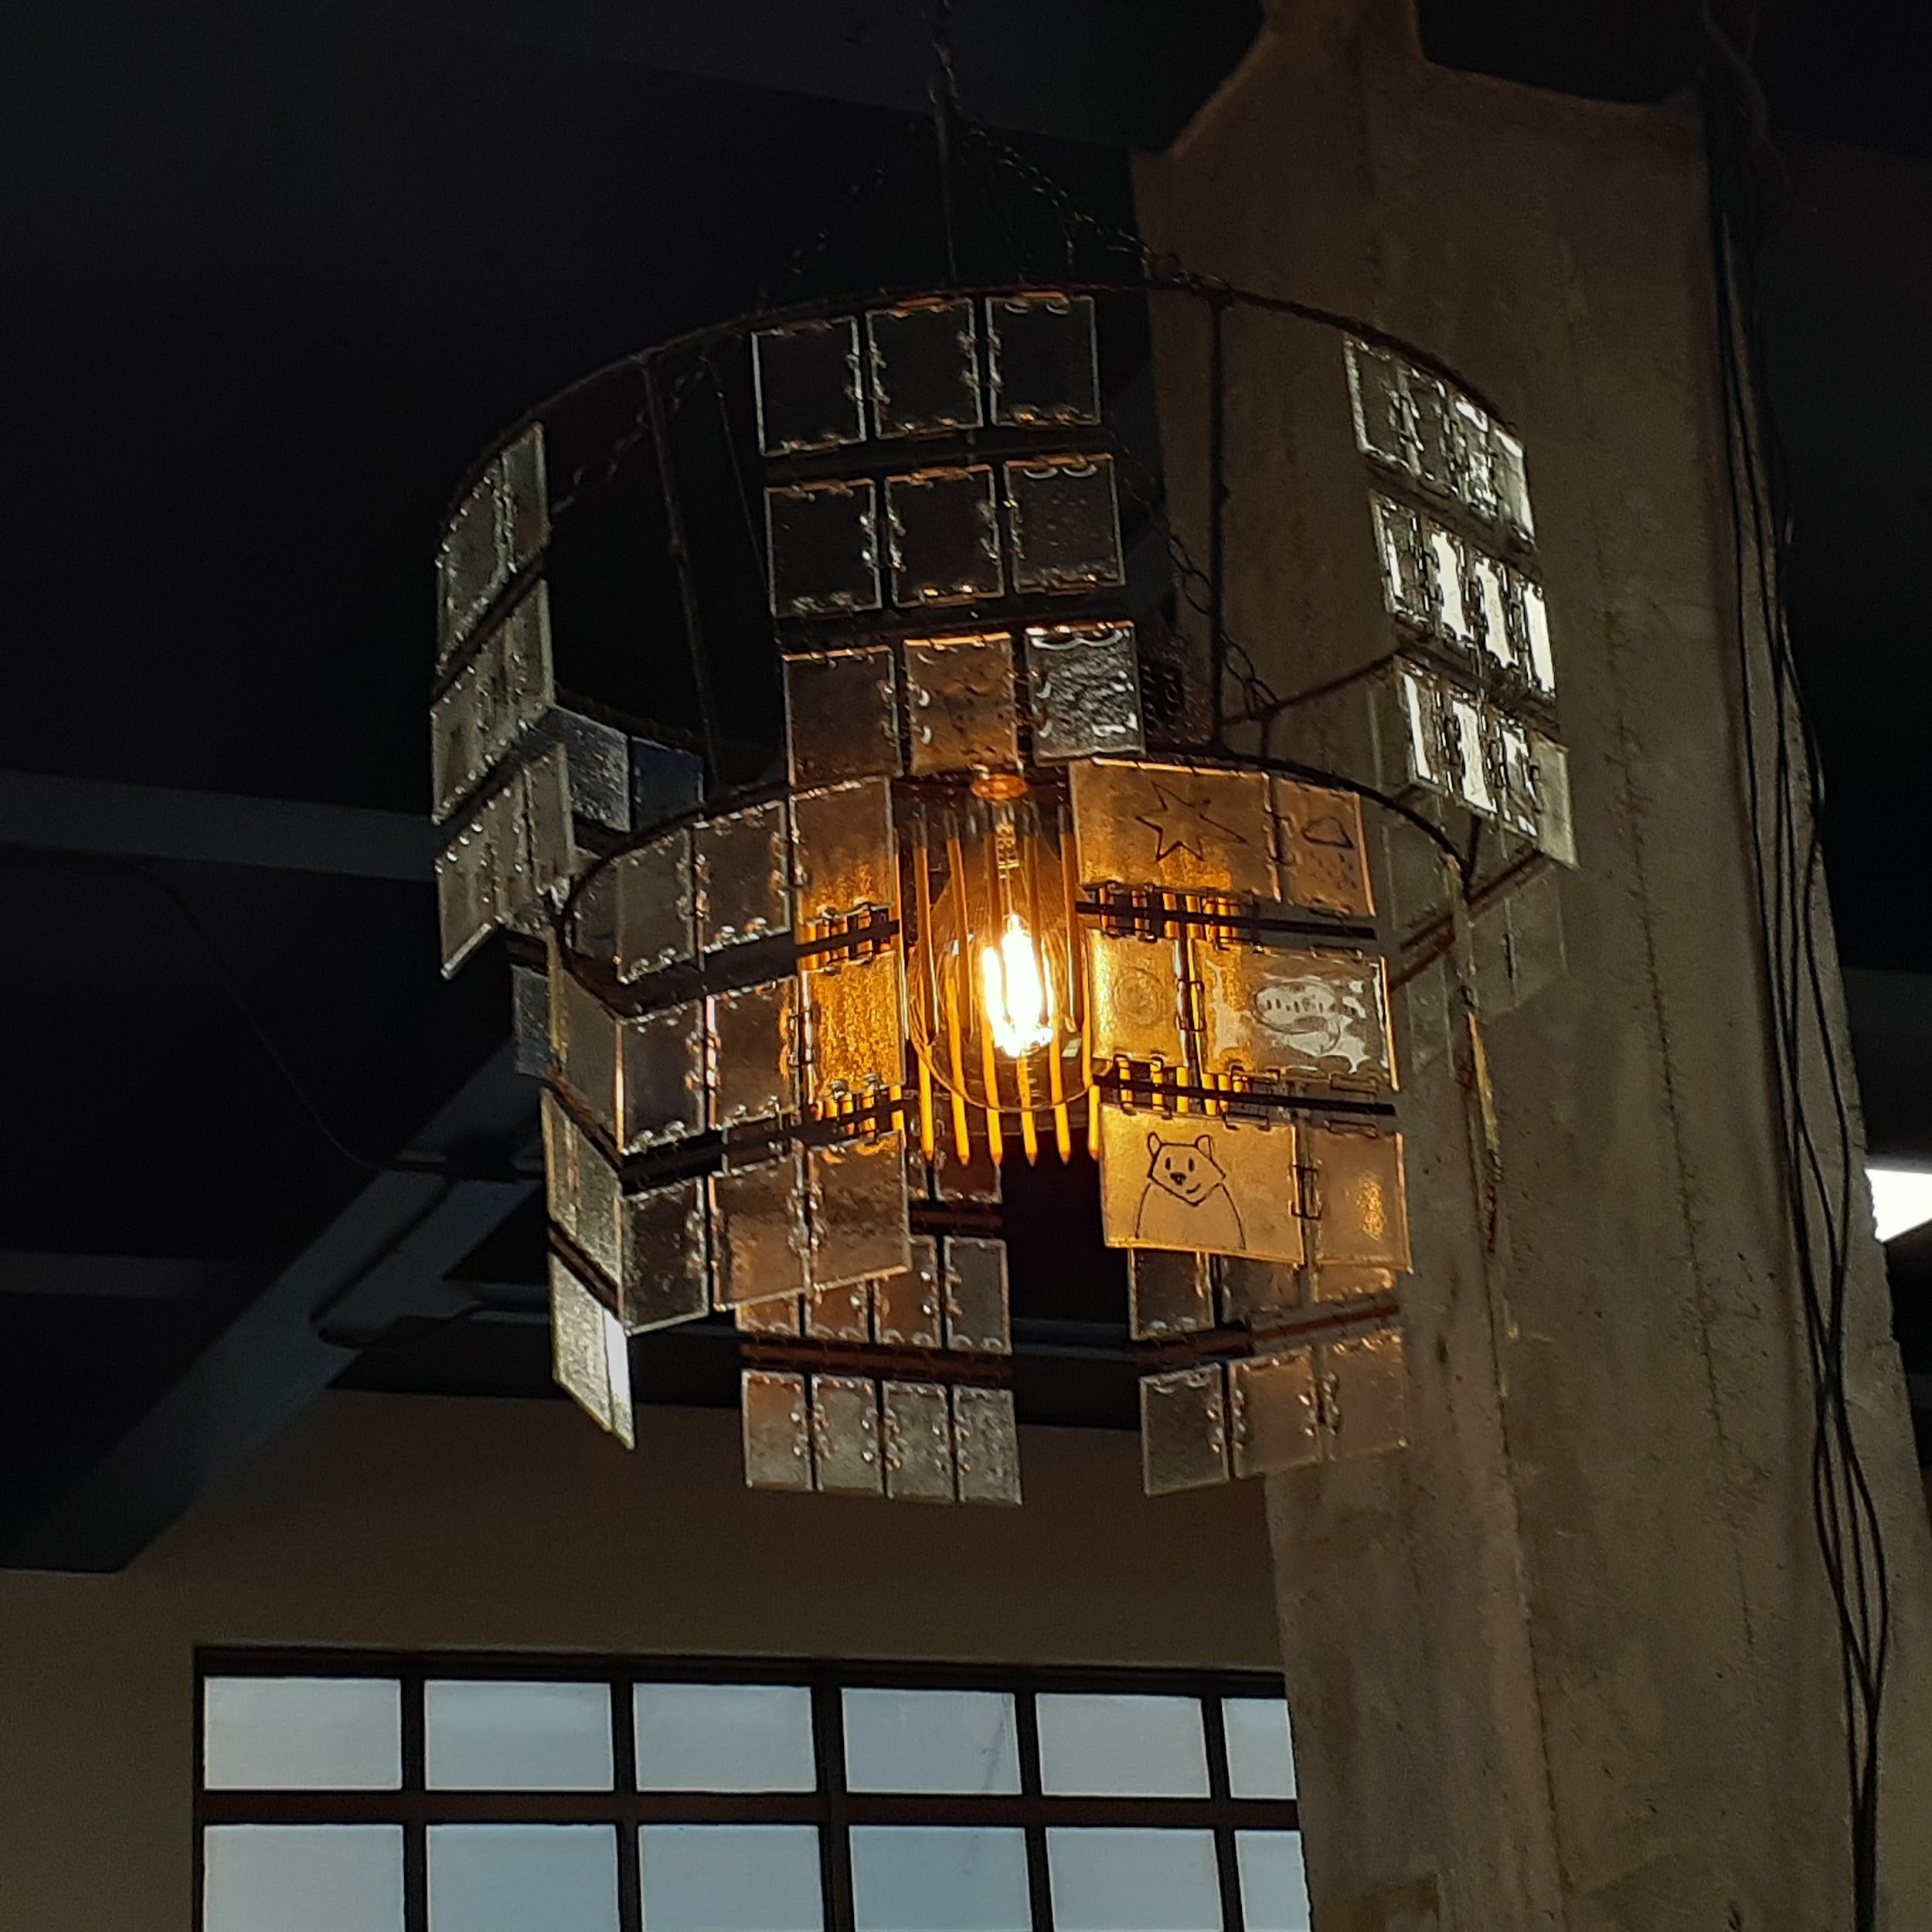

**AK Robotics Chand**

**2023**

**Kiln fused glass, non-traditional pate de verre, found metal, lighting**

**40 x 36 x 36”**

Created as a commissioned piece for Alaska Robotics Gallery, this chandelier is created of glass pendants using multiple kilned glass techniques and reclaimed found objects, inspired by the spirit of Alaska Robotics as a creative space. Utilizing waste sheet glass the comic book inspired glass panels are embellished with drawings by Pat Race (Gallery co-owner) and kiln fused with copper inclusions. The center is made of glass pencils constructed using a non-traditional pate-de-verre technique. The glass works are then suspended from a reused shrimp pot acting as a frame.

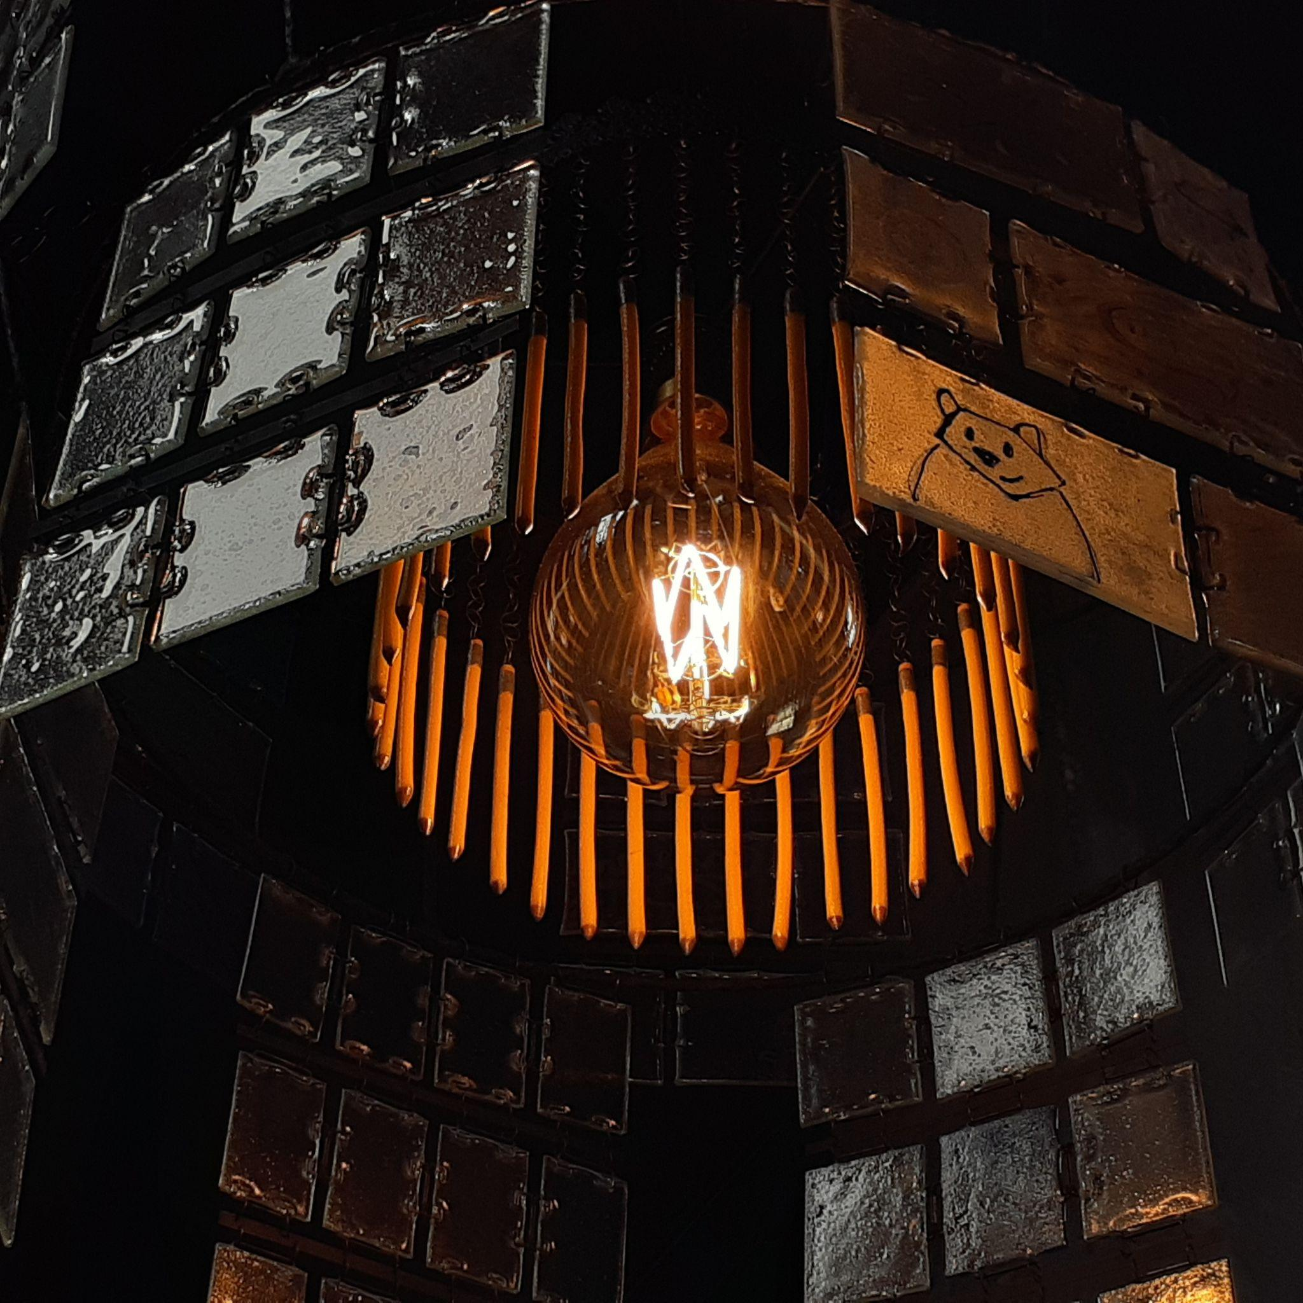

Pate de verre pencils in process:

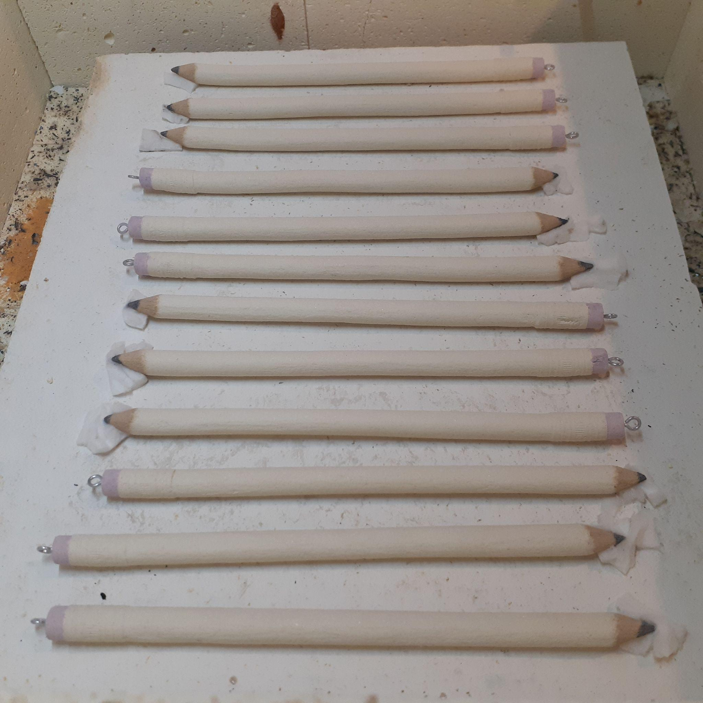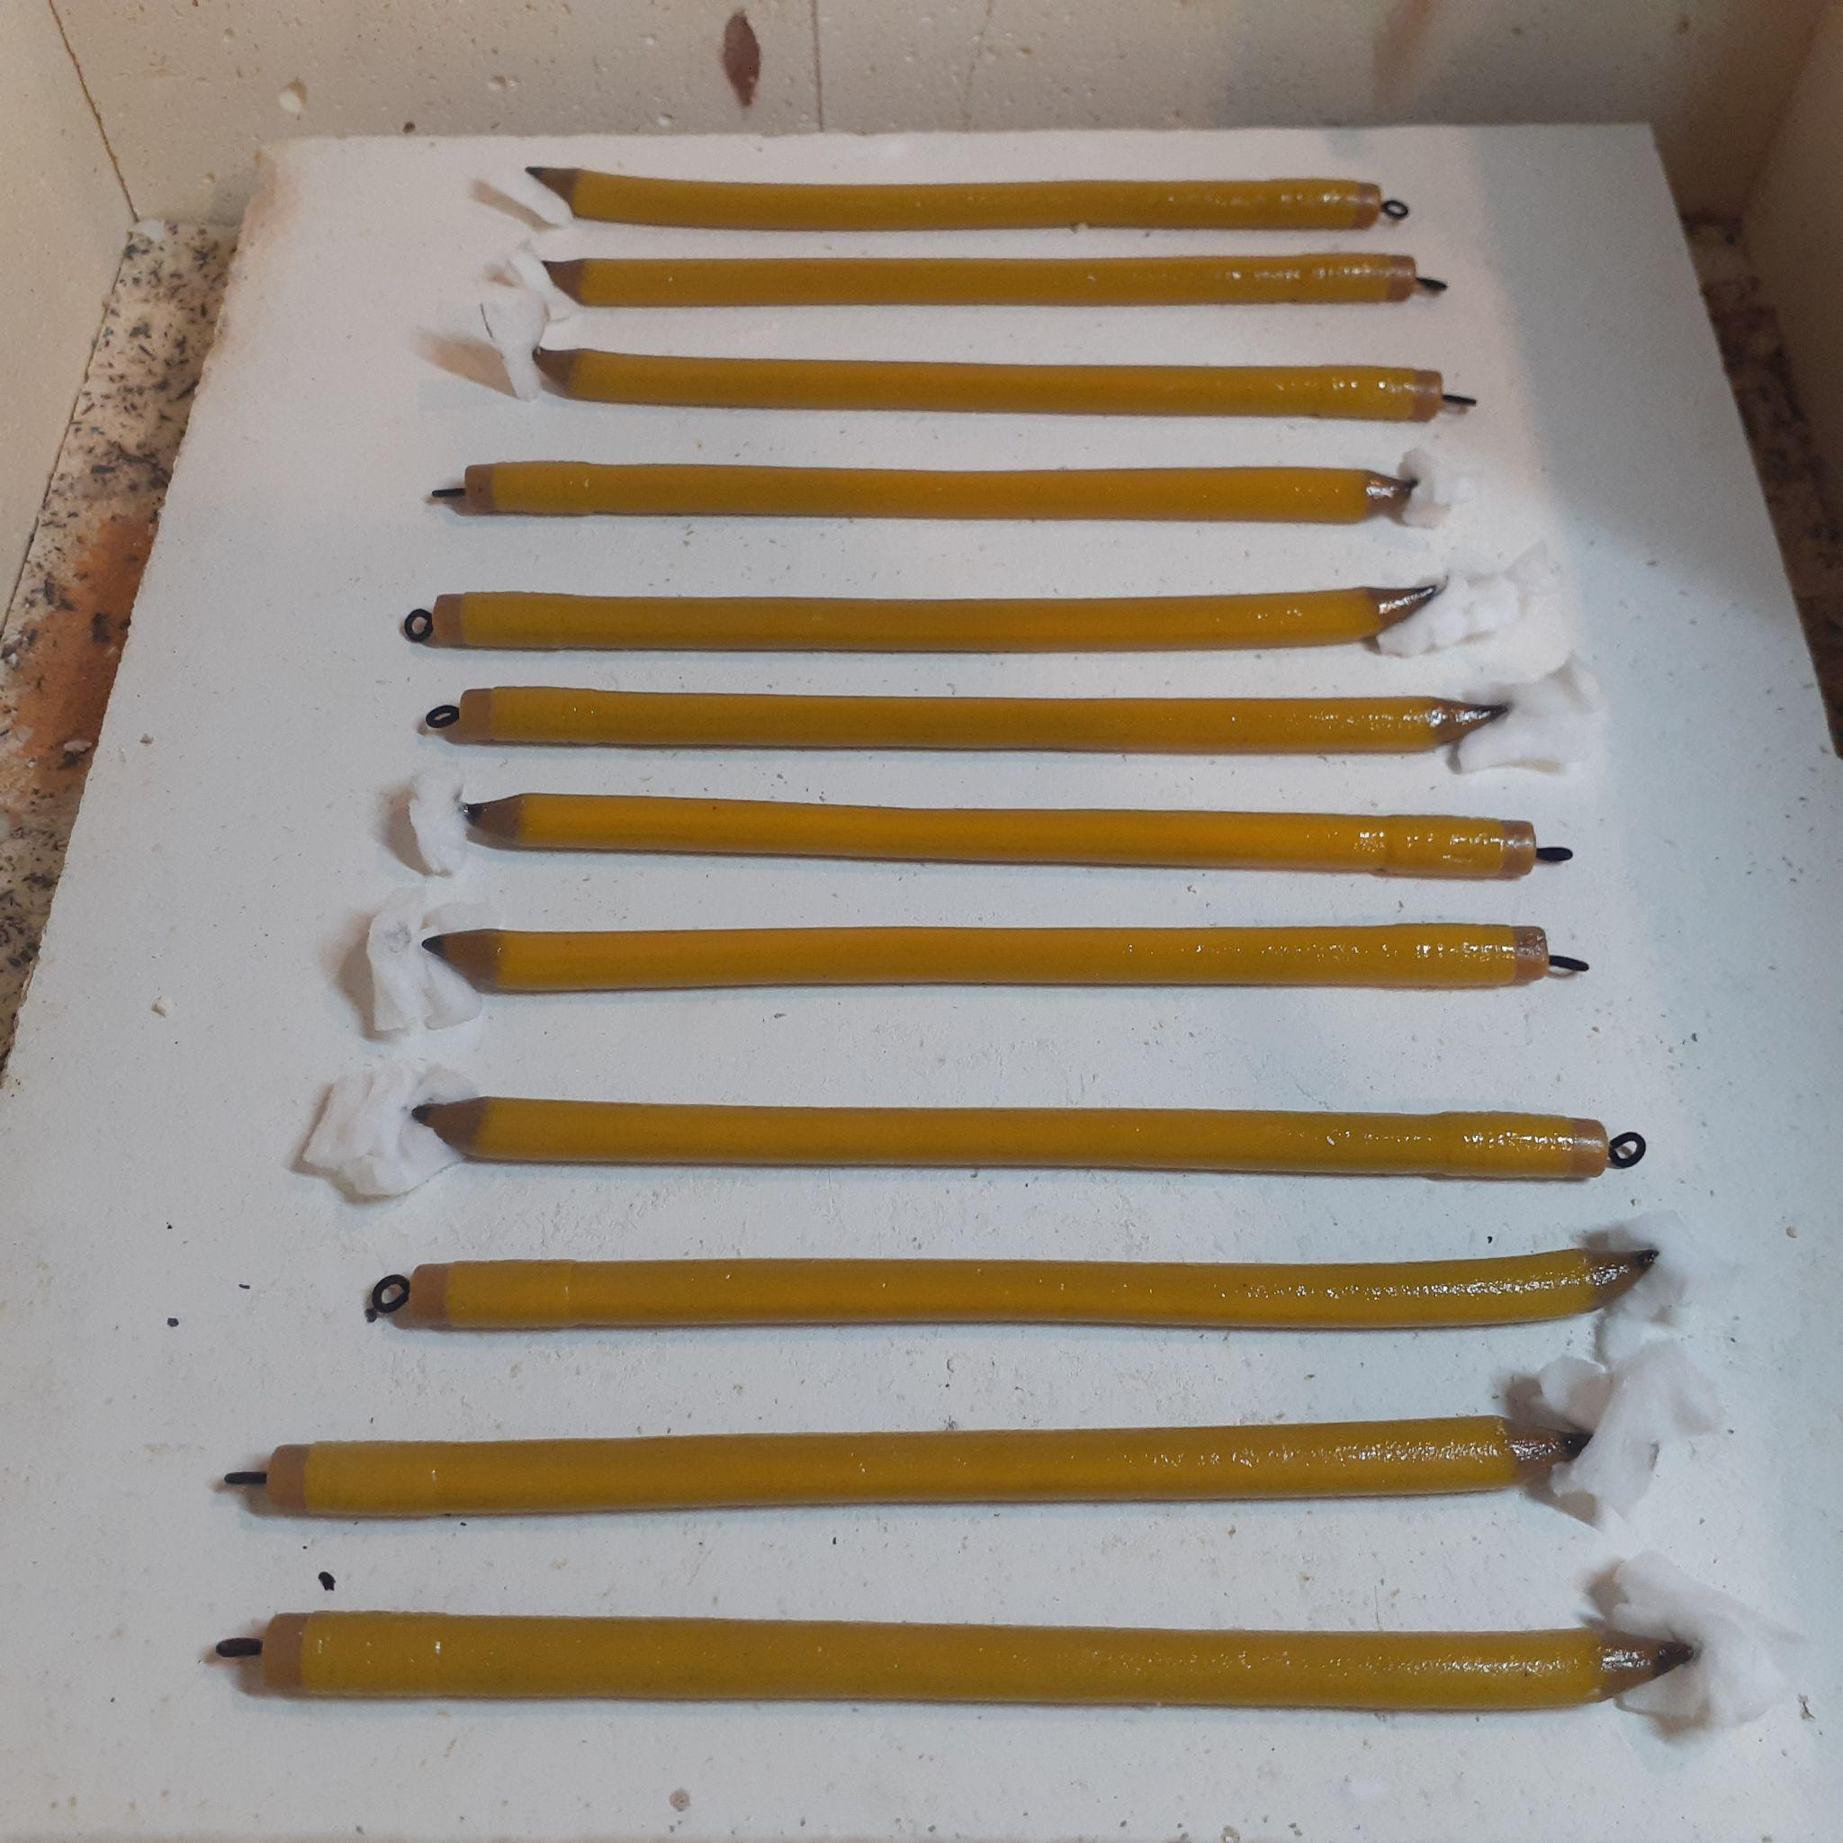

Imperial Saloon

Tiff’s Shop

GoldTown

